If you are on a Windows machine and get an error message saying something along the lines of:
conda : The term 'conda' is not recognized as the name of a cmdlet
The solution (hopefully) is to add Conda to your path/environment variables.
Follow this guide:
- Press the Windows-button and search for “edit the system environment variables”
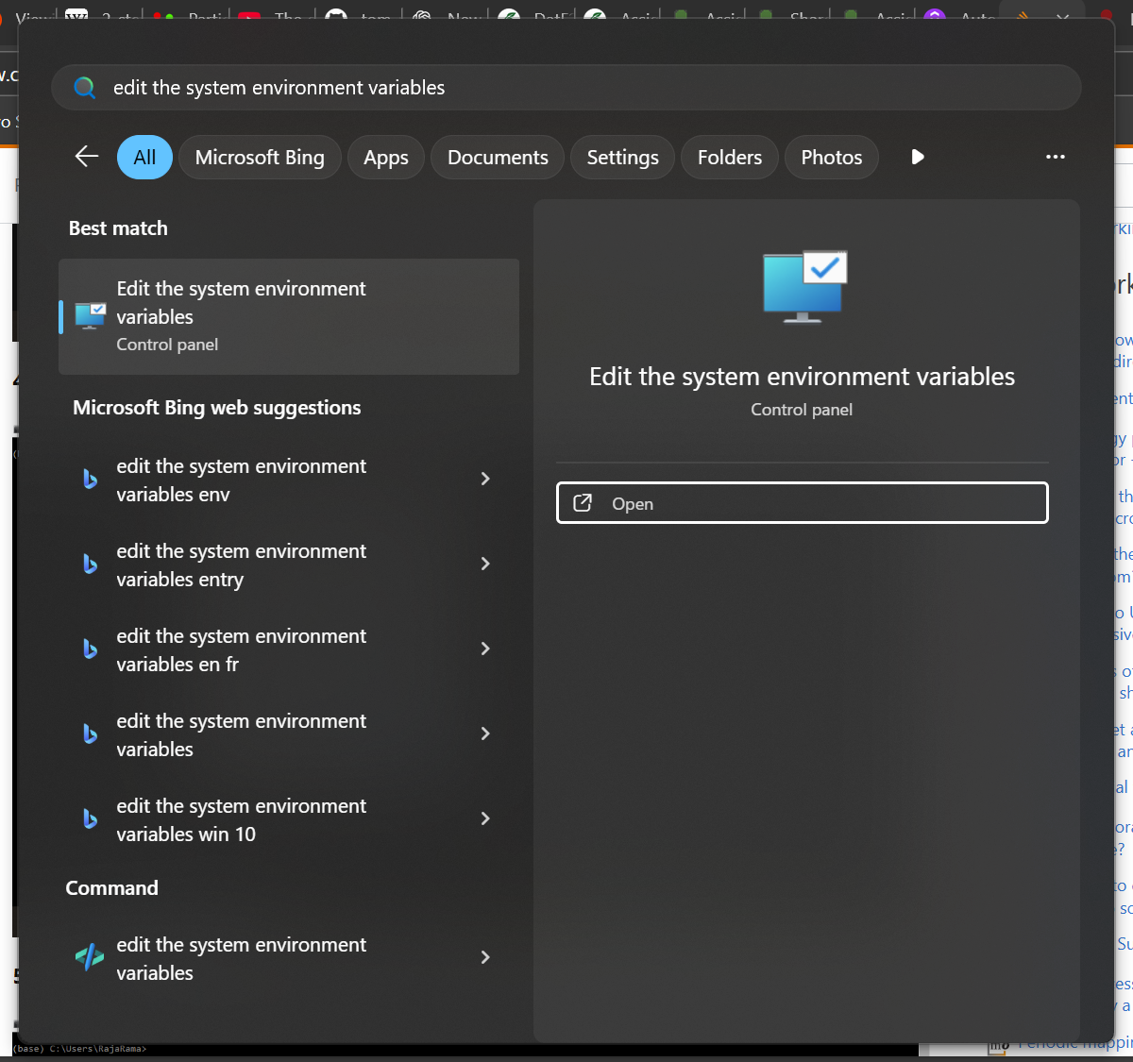
- Press the “Environment Variables” button: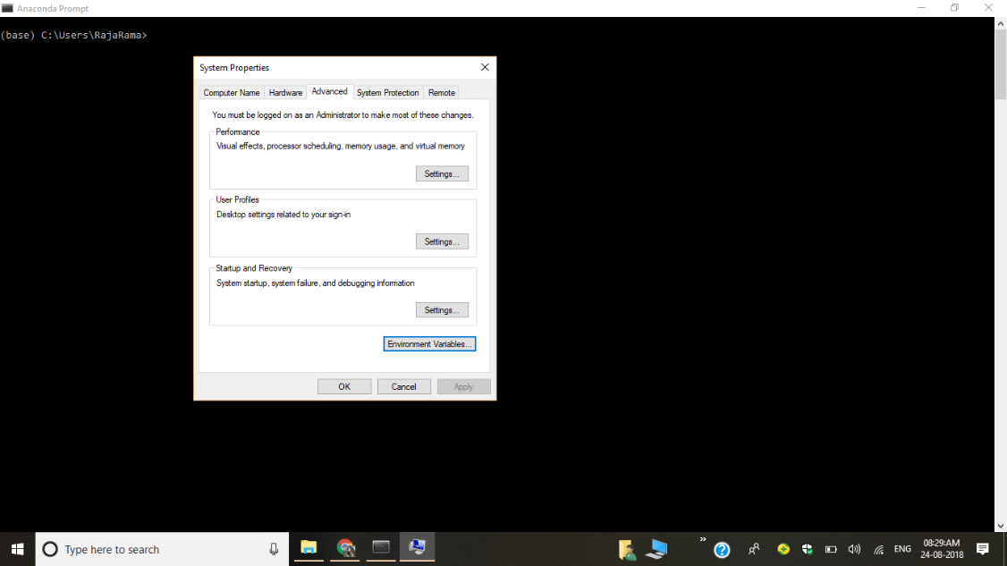
- Open anaconda-prompt. Type “where conda”. This will give you the location of anaconda on your pc.
- On three empty lines of the path variables, click “edit” and add the following (where the path is replaced by the location you found in step 3):
  - C:\...\Anaconda3\Scripts
  - C:\...\Anaconda3
  - C:\...\Anaconda3\Library\bin
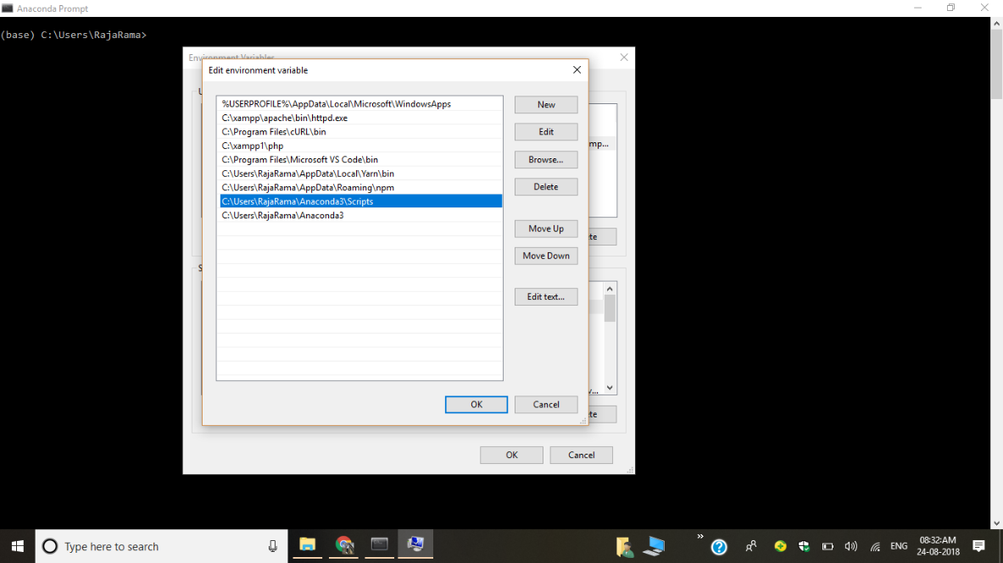
- Restart your computer :)

